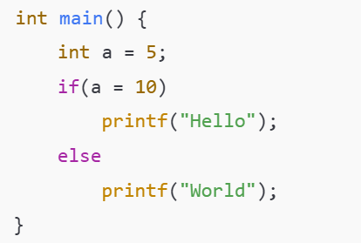
OUTPUT: World

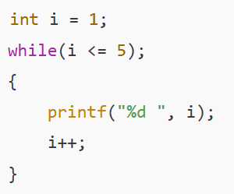

OUTPUT: 1 2 3 4 5

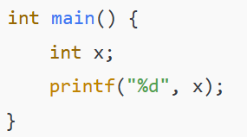
Output: it won’t print anything

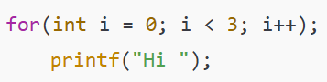
Output: Hi Hi Hi

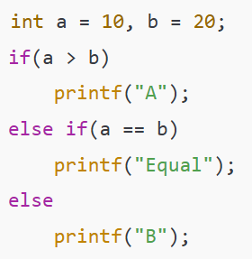
Output: B

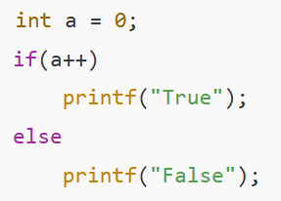
Output: Not Sure May be False

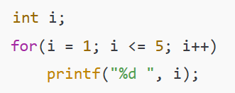
Output:1 2 3 4 5

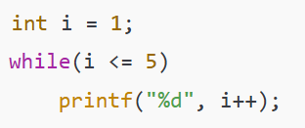
Output: run time error, we should use “I” instead of I ++

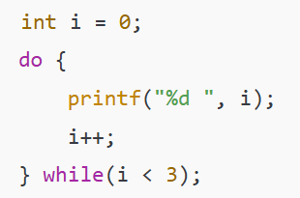

Output:

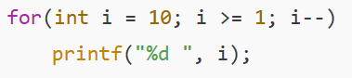
Output:10 9 8 7 6 5 4 3 2 1

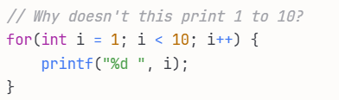
Answer:ok

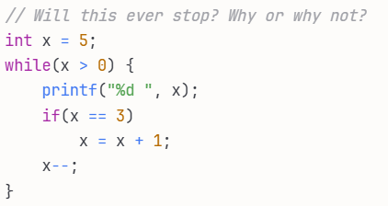
Answer: it loops infinitely 55555

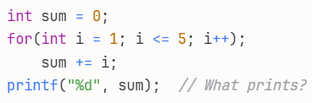
Output: 1 2 3 4 5
Sum = sum + I;

How would you modify the code below to just print Odd Numbers:
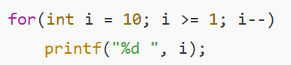
Code:
For(int I =10; i>=1; i--)
If (I %2 ==0){
Printf(“%d”, i);

---------------

